MYSQL QUERY FOR

FP20 April inventory management challenge

**Stock Analysis& inventory levels**

**1 -- Product category with the highest stock quantity**

select Category, sum(Stock_Quantity) as total_stock_quantity

from inventory_data

group by Category

order by total_stock_quantity desc

limit 1;

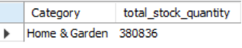

**2 -- NO product have stock quantity below their reorder point**

select count(Product_Name)

from inventory_data

where Stock_Quantity< Reorder_Point;

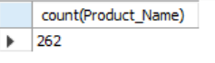

**3 -- Total Min quantity required to restock all products below the reorder point**

select sum(Min_Order_Quantity) as total_min_order_quantity

from inventory_data

where Stock_Quantity< Reorder_point;

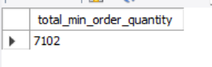

**Supplier & Restocking Performance**

**4 -- Suppliers with the highest average lead time**

select supplier_ID, avg(Lead_Time_Days) as average_lead_time

from inventory_data

group by Supplier_ID

order by average_lead_time desc

limit 1;

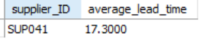

**5--What is the average time since the last restock for products marked as "Out of Stock"?**

SELECT AVG(DATEDIFF(CURDATE(), last_restock_date)) AS average_days_since_last_restock

FROM inventory_data

WHERE stock_quantity = 'Out of Stock'

LIMIT 200;

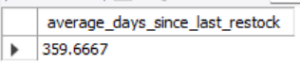

**6--Identify the months when the highest number of products were restocked - are there any seasonal trends**

SELECT monthname(Last_Restock_Date) AS restock_month,

COUNT(product_id) AS total_products_restocked

FROM inventory_data

GROUP BY monthname(Last_Restock_Date)

ORDER BY total_products_restocked DESC;

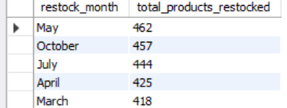

Cost & Pricing Analysis

7--the top 5 most expensive products (by unit price) and their categories

select Category,Unit_Price

from inventory_data

order by Unit_Price desc

limit 5;

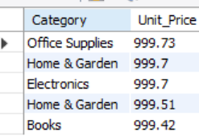

**8--product category has the fastest turnover based on stock quantity and lead time**

SELECT Category,

AVG( Stock_Quantity/ Lead_Time_Days) AS turnover_rate

FROM inventory_data

GROUP BY Category

ORDER BY turnover_rate DESC

LIMIT 1;

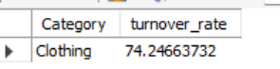

**Warehouse & Geographic insights**

**9--Which warehouse location has the highest number of products stored?**

SELECT warehouse_location,

COUNT(product_id) AS total_products

FROM inventory_data

GROUP BY warehouse_location

ORDER BY total_products DESC

LIMIT 1;

**10 --country with the most stocked items**

SELECT country,

SUM(stock_quantity) AS total_stock

FROM inventory_data

GROUP BY country

ORDER BY total_stock DESC

LIMIT 1;



**11 --top 3 counties with the highest stocked quantities by product categories**

SELECT Country, Category,

SUM(stock_quantity) AS total_category_stock

FROM inventory_data

GROUP BY Country,Category

ORDER BY total_category_stock DESC

LIMIT 3;

